## Database Management Systems

**“**Hospital Management System”

Description: The major workflow of this project covers all the major tasks being performed in a hospital related to a database. Hence it is divided in some basic macroscopic modules which further divide into some sub-modules. We have already submitted the ERD and Relational Schema for this project.

We have divided this report into major module’s functionality.

* A Patient can get an appointment with a doctor.
* A patient can get admitted in a ward.
* A doctor can see the complete medical record/history of a patient.
* A doctor can write a prescription to a patient.
* A Bill can be prepared for a patient.

This database can handle daily tasks of any General Hospital System.

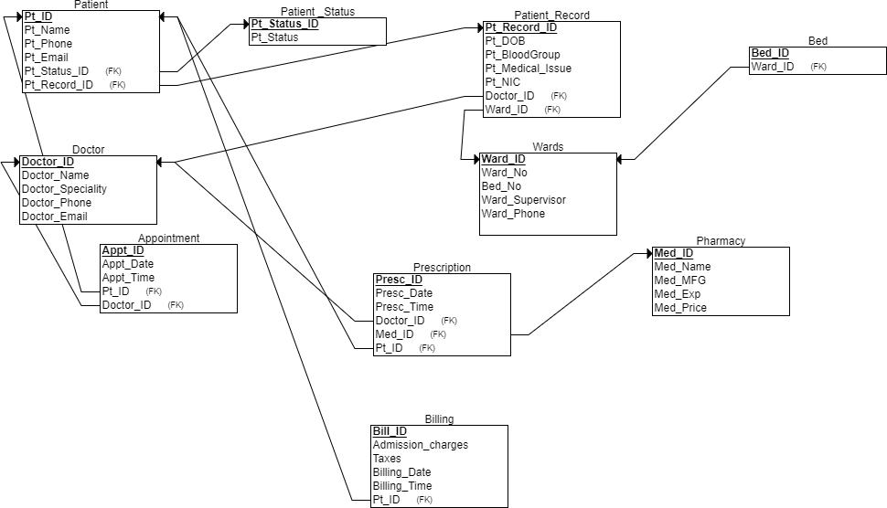

1. Displaying Data present in all the tables

Patient Table: It gives general patient information.

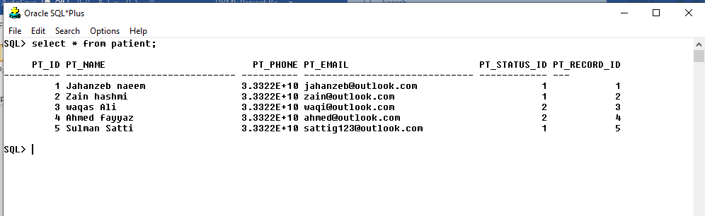

Patient status Table: Whether the patient is admitted one or visiting

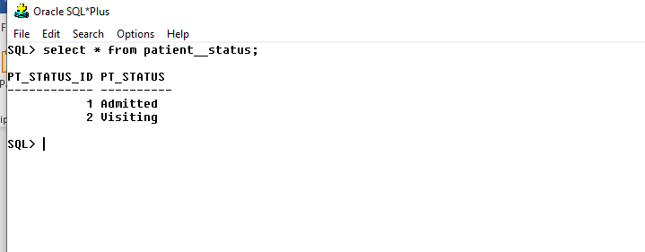

Doctor Table: It gives general information of a doctor.

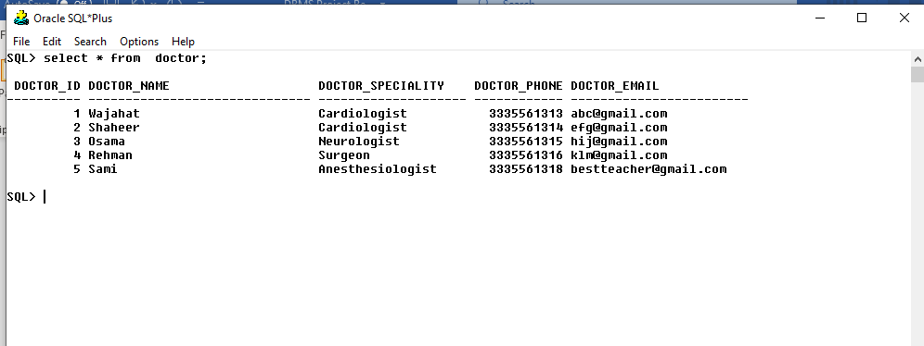

Patient Record Table: It gives complete medical history of a patient.

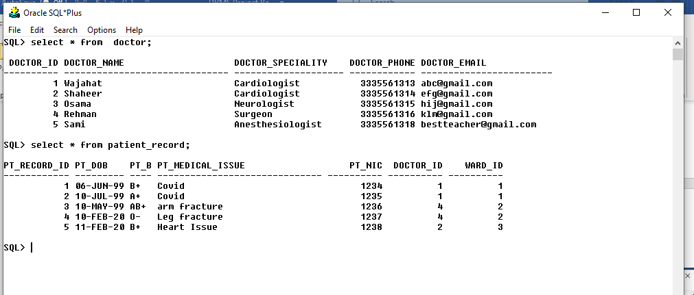

Wards: It gives general information about the wards

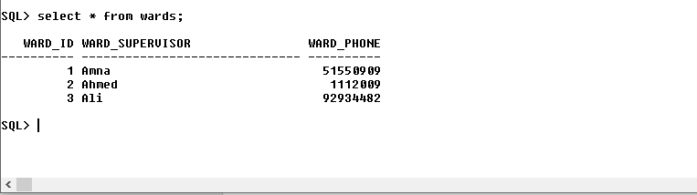

Bed Table: This table gives information about beds in a ward.

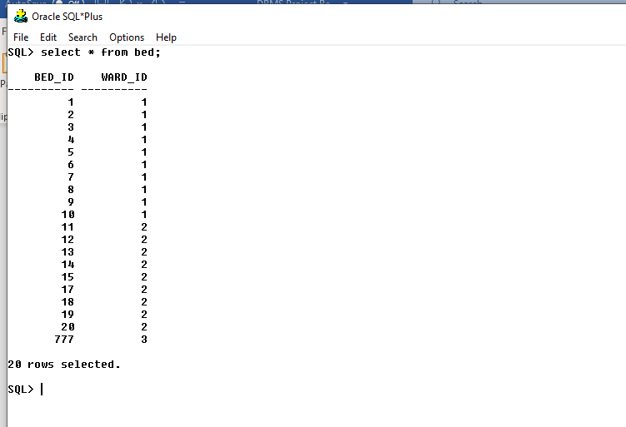

Appointment Table: This table gives all details related to appointment of patient with doctor.

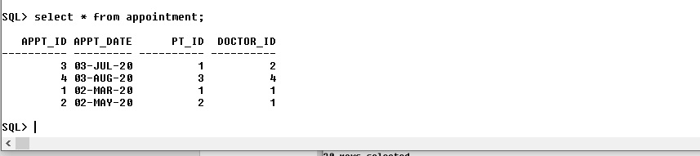

Pharmacy Table: Gives details about pharmaceutical products like vaccines, medicines.

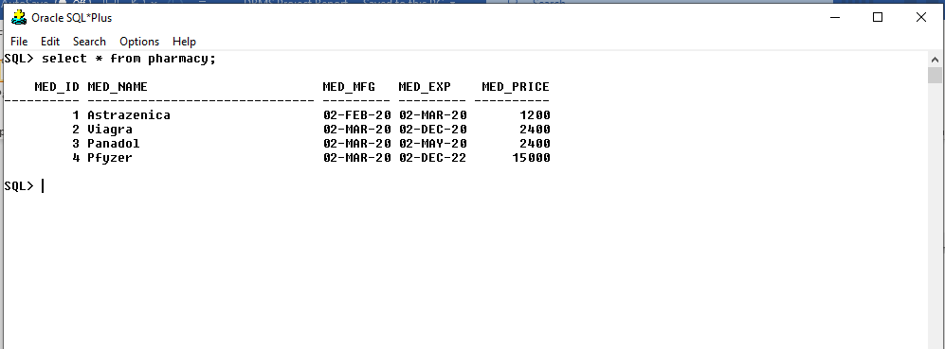

Billing Table: It gives bill of the patient including taxes and all.

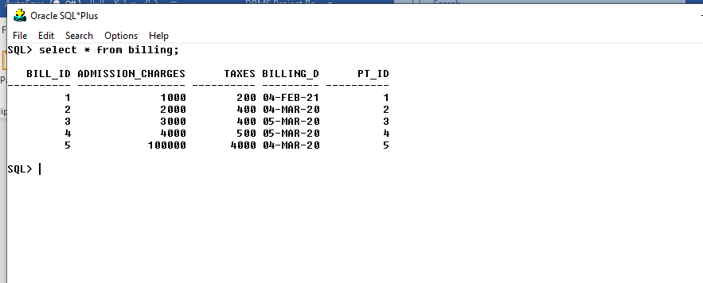

Prescription Table: It gives all information of a prescription.

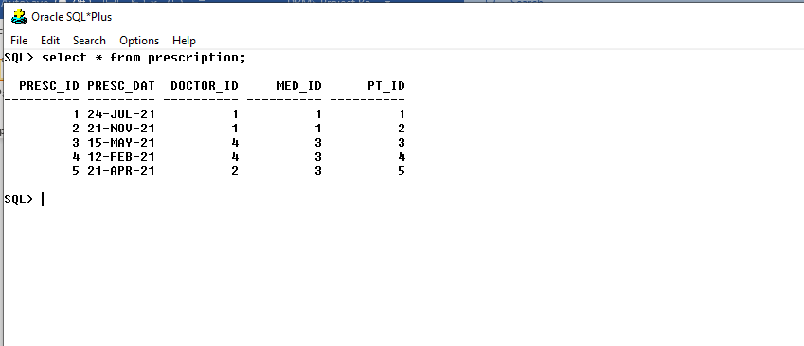

1. Classifying which patients from DB are visiting and which are admitted in ward

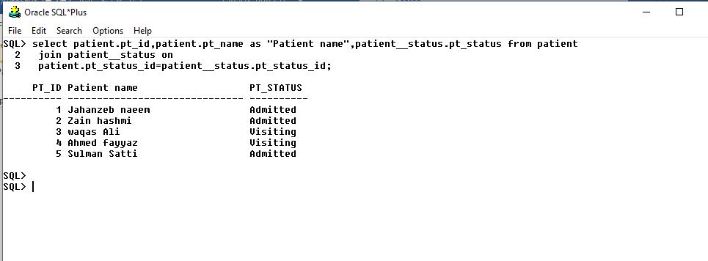

1. Setting Patient Appointment with Doctor

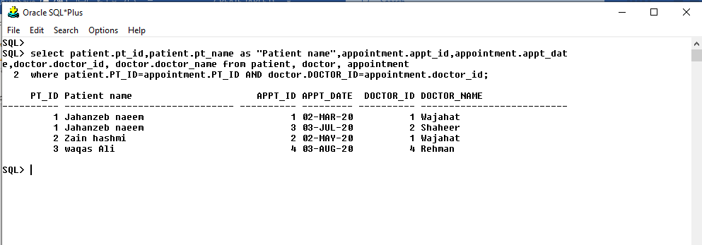

1. Displaying prescription prescribed by doctor.

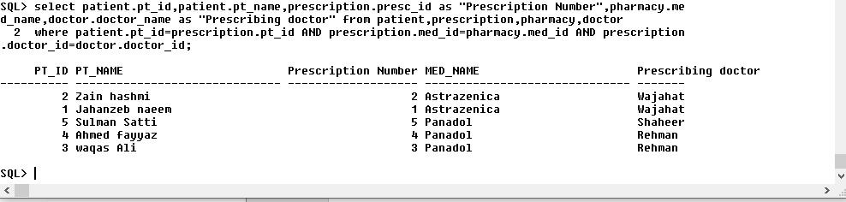

1. Creating Total Bill of the patients:

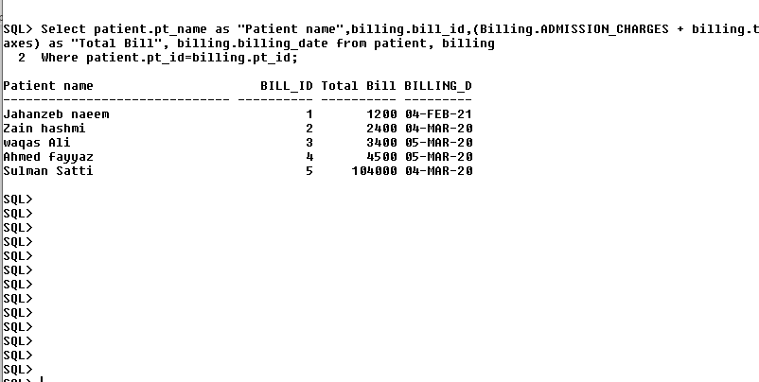

1. Total amount Billed by Hospital to Patients:

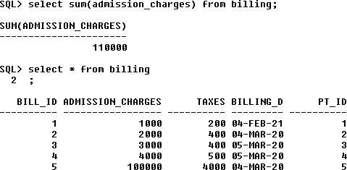

# Thank ou

* *